HANOI UNIVERSITY OF SCIENCE AND TECHNOLOGY

School of Information and Communications Technology

Interface Design

AIMS: An Internet Media Store

Software Design and Construction

Group 02

Trần Xuân Bách 20204634

Nguyễn Ngọc Quỳnh Anh 20204631

Nguyễn Vũ Thục Anh 20204631

Vũ Đức Anh 20193985

*Hanoi, 1/2024*

Contents

1. User Interface Design 3

Screen transition flow 3

Hello Page 4

Home Page 4

Cart Page 4

Delivery Information Form Page 5

Invoice Page 5

List Invoice Page 6

Pay Order Page 7

Detail Product Page 7

2. System Interface Design 8

2.1. Identify subsystems 8

2.2. Identify subsystem interface 8

2.3. Subsystem design 8

# User Interface Design

## Screen transition flow

## Hello Page

## Home Page

|  |  |  |  |  |
| --- | --- | --- | --- | --- |
| AIMS Software | | Date of creation | Person in charge | |
| Screen specification | Home page screen | 27/10/2023 | Nguyễn Ngọc Quỳnh Anh | |
|  | | Control | Operator | Function |
| Search Input Area | Type | Input Search Keyword |
| Search Button | Click | Search Media with input in search area |
| Cart Button | Click | Display Cart Page |
| Area for displaying Banner | Initial | Display Banner |
| Area for displaying Media | Initial | Display Media |
| Next Button | Click | Display next page |
| Pre Button | Click | Display previous page |

## Cart Page

|  |  |  |  |  |
| --- | --- | --- | --- | --- |
| AIMS Software | | Date of creation | Person in charge | |
| Screen specification | Home page screen | 27/10/2023 | Nguyễn Ngọc Quỳnh Anh | |
|  | | Control | Operator | Function |
| Area for displaying Price | Initial | Display price |
| Area for displaying Media | Initial | Display Media |
| Place order Button | Click | Display Delivery Form |
| Delete Button | Click | Remove product from cart |

## Delivery Information Form Page

|  |  |  |  |  |
| --- | --- | --- | --- | --- |
| AIMS Software | | Date of creation | Person in charge | |
| Screen specification | Home page screen | 27/10/2023 | Nguyễn Ngọc Quỳnh Anh | |
|  | | Control | Operator | Function |
| Name Input area | Type | Set name reciever |
| Phone input area | Type | Set phone reciever |
| Province Input area | Choose | Set province reciever |
| Address Input area | Type | Set address reciever |
| Instruction Input area | Type | Set instruction reciever |
| Submit button | Click | Send form and display Rush Order Form Page or Invoice Page |

## Invoice Page

|  |  |  |  |  |
| --- | --- | --- | --- | --- |
| AIMS Software | | Date of creation | Person in charge | |
| Screen specification | Home page screen | 27/10/2023 | Nguyễn Ngọc Quỳnh Anh | |
|  | | Control | Operator | Function |
| Area for displaying Price | Initial | Display price |
| Area for displaying Delivery Information | Initial | Display Delivery Information |
| Area for displaying Media | Initial | Display Media |
| Confirm order Button | Click | Display Payment Page |

## List Invoice Page

|  |  |  |  |  |
| --- | --- | --- | --- | --- |
| AIMS Software | | Date of creation | Person in charge | |
| Screen specification | Home page screen | 29/11/2023 | Trần Xuân Bách | |
|  | | Control | Operator | Function |
| Delete  Button | Click | DeleteInvoice |
| Refund  Button | Click | RefundOrder |
| Payment  Buton | Click | PayOrder |

## Pay Order Page

|  |  |  |  |  |
| --- | --- | --- | --- | --- |
| AIMS Software | | Date of creation | Person in charge | |
| Screen specification | Pay Order page screen | 29/11/2023 | Trần Xuân Bách | |
|  | | Control | Operator | Function |
| Payment Link | Inital | Display paypal sanbox link to pay order |
| Go to link button | Click | Go to link to pay order by Paypal |
| Confirm Payment  Buton | Click | Confirm payment |

## Detail Product Page

|  |  |  |  |  |
| --- | --- | --- | --- | --- |
| AIMS Software | | Date of creation | Person in charge | |
| Screen specification | Detail product page screen | 29/11/2023 | Nguyễn Vũ Thục Anh | |
|  | | Control | Operator | Function |
|  |  |  |
|  |  |  |

# 2. System Interface Design

## 2.1. Identify subsystems

## 2.2. Identify subsystem interface

## 2.3. Subsystem design

**Distribute subsystem behavior to subsystem elements**

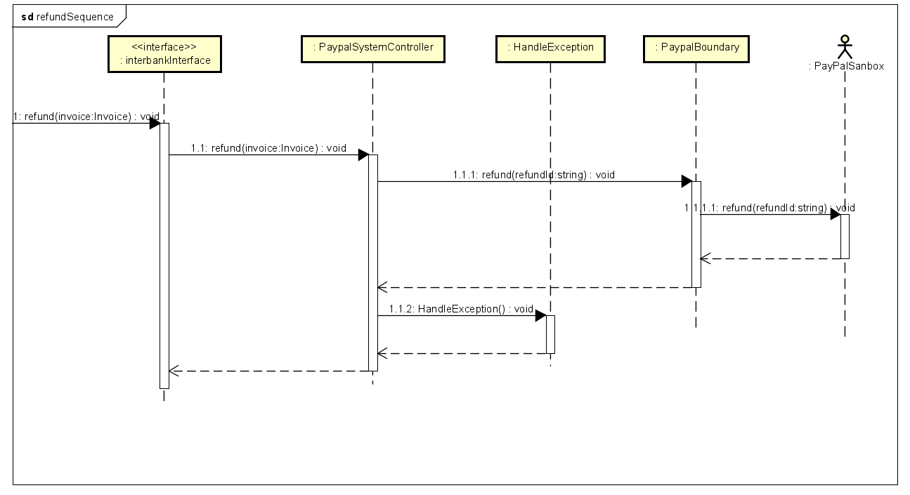

**Document subsystem elements**

**